UNIVERSITY OF WAH (UOW)

DEPARTMENT OF COMPUTER SCIENCE



BSCS 3RD B

REG #: UW-24-CS-BS-088

SUBMITTED BY: SAADI SAFDAR

SUBMITTED TO: SIR. HASSAN SHAFAQAT

COURSE TITLE: COMPUTER NETWORKS

COURSE CODE: CS – 241 L

LAB REPORT # 4

CISCO PACKET TRACER
- Cisco Packet Tracer is Launched.
- 4 hubs are added
- 4 PCs and 4 Laptops are added
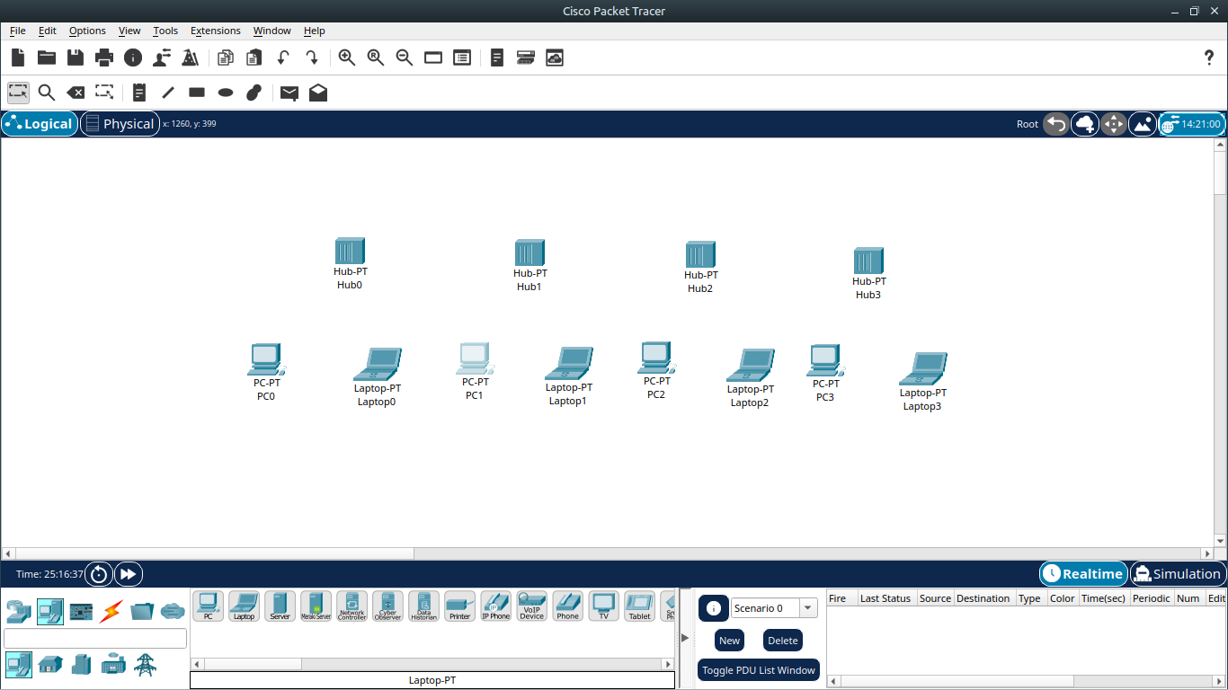
- Every End Device(PCs & Laptops) is connected to Network Device(Hub) by Connection: Copper Straight-Through by FastEthernet
- Every End Device(Hubs) is connected to each other by Connection: Copper-CrossWire
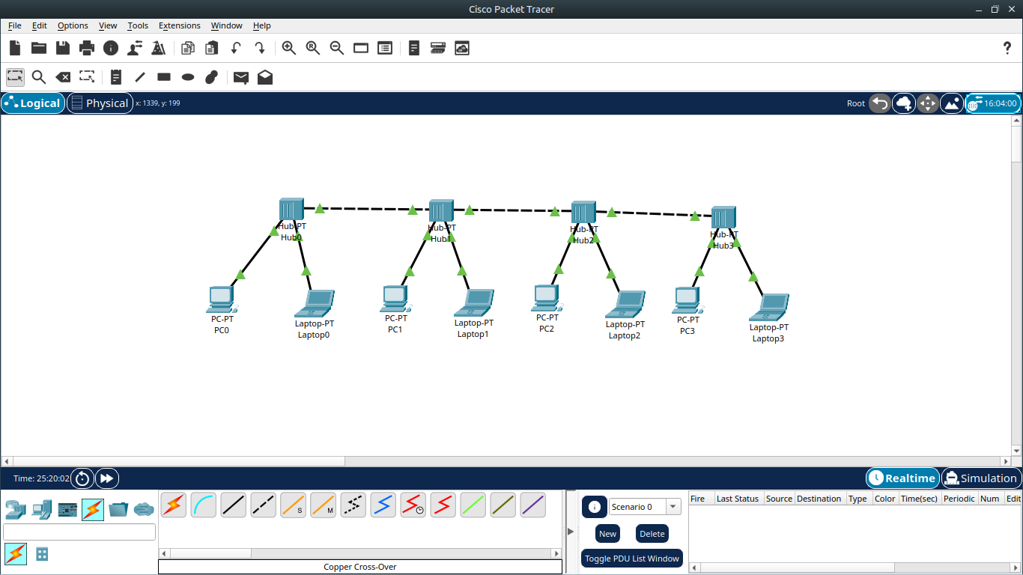

- IP Configuration for End Devices are setted
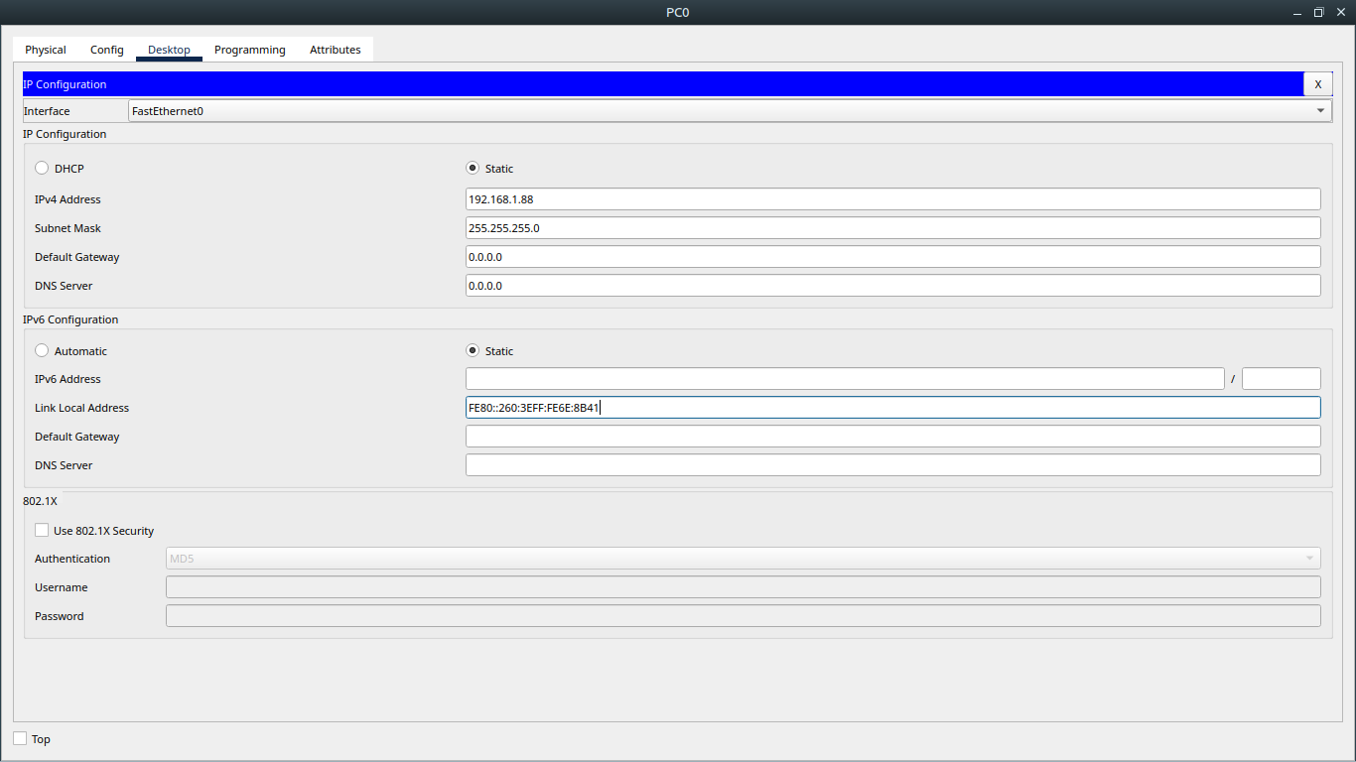
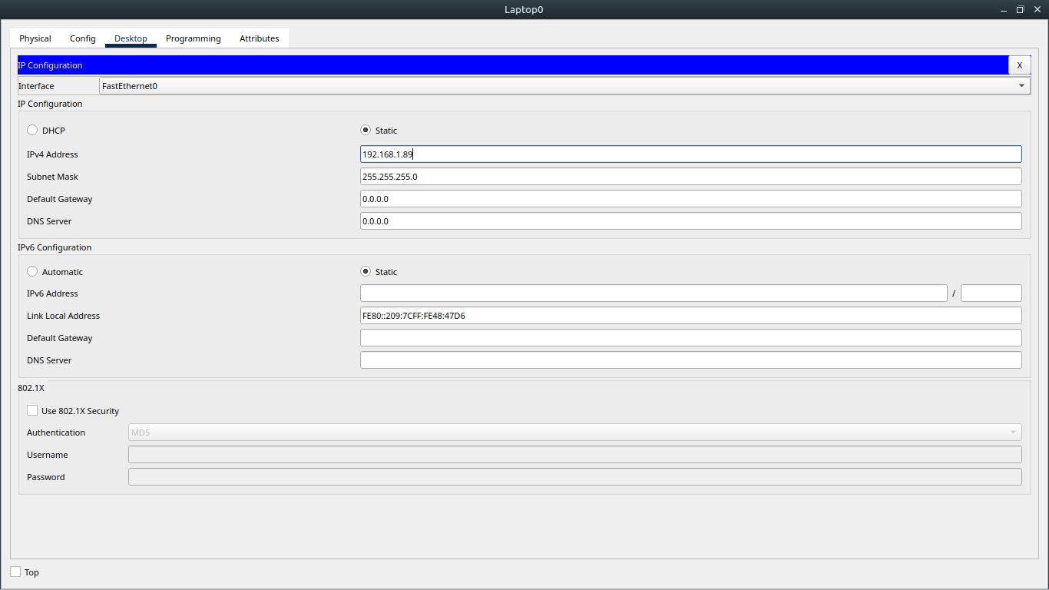
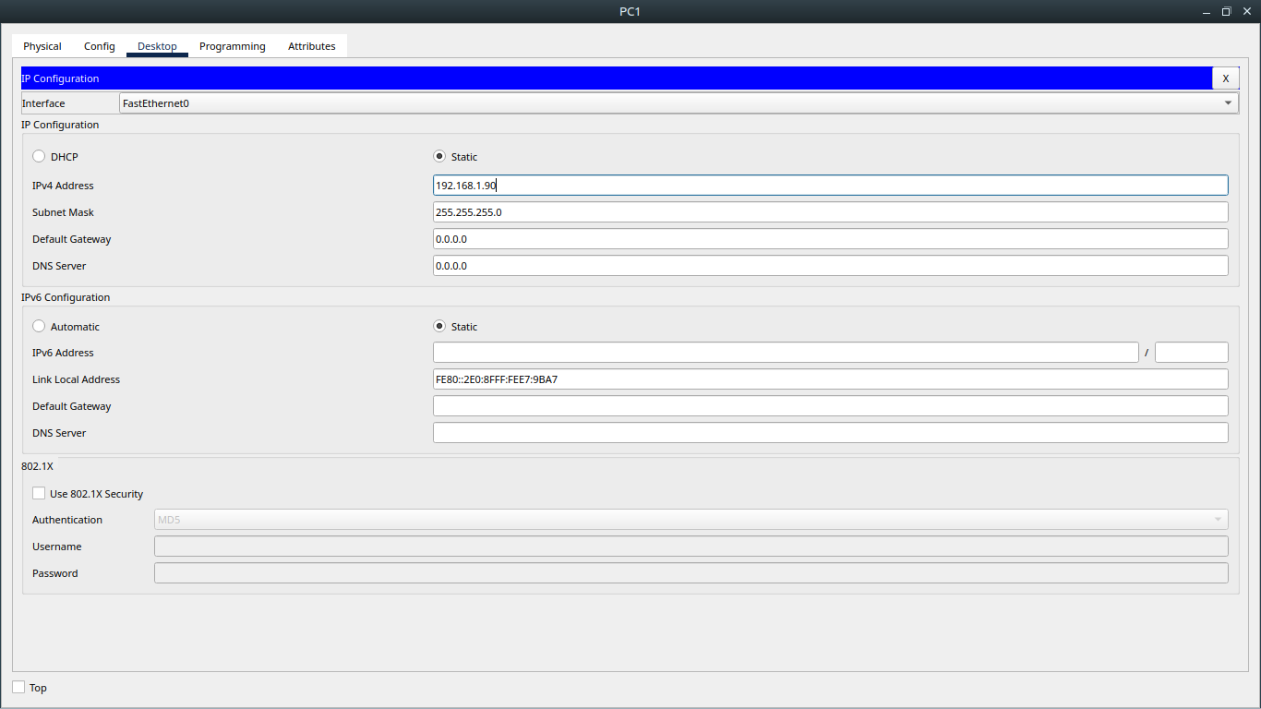
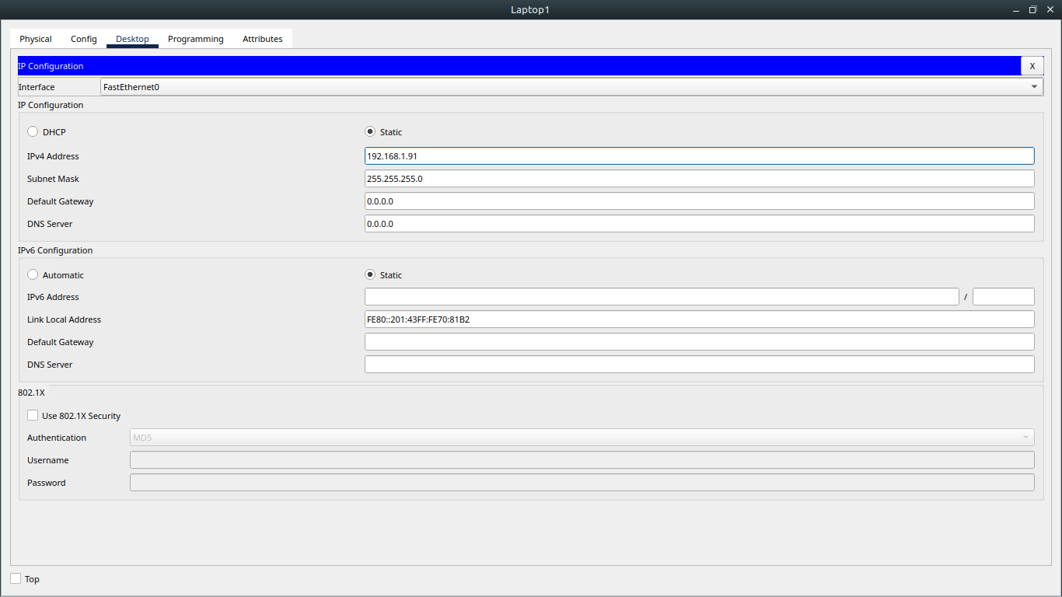

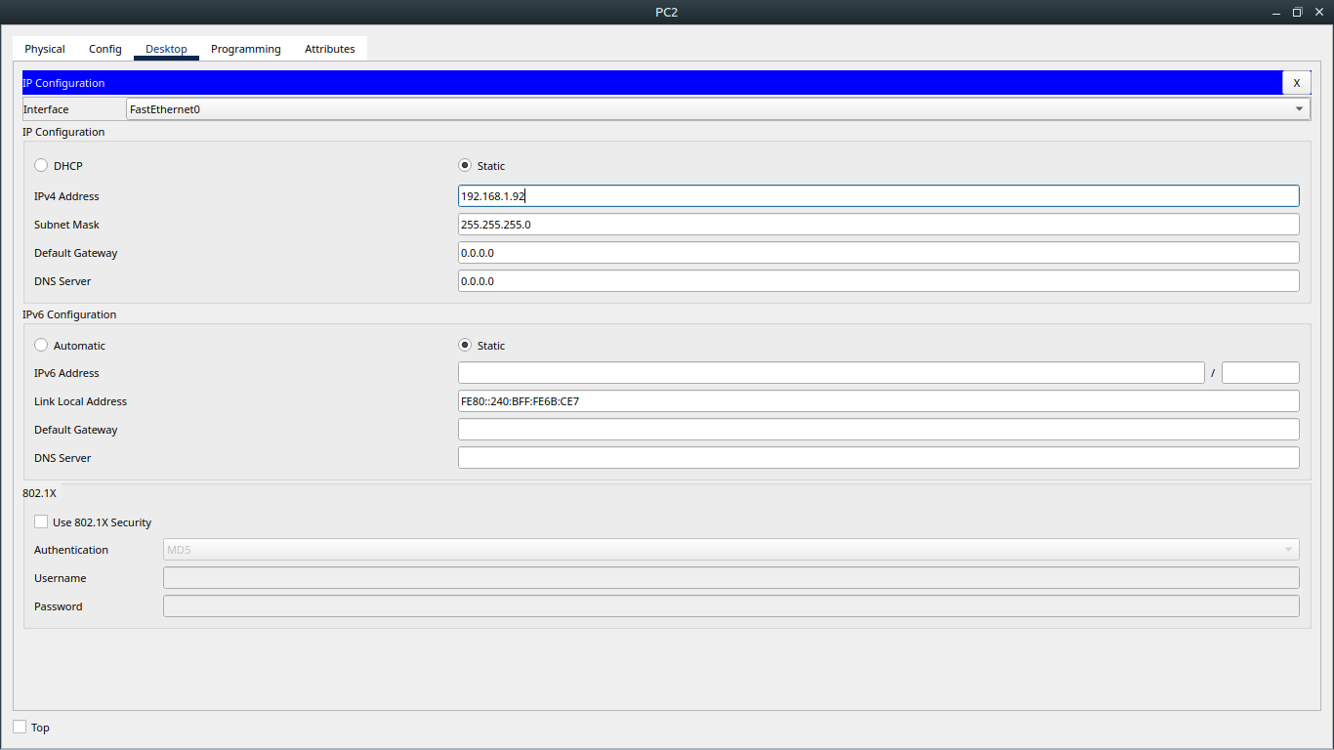

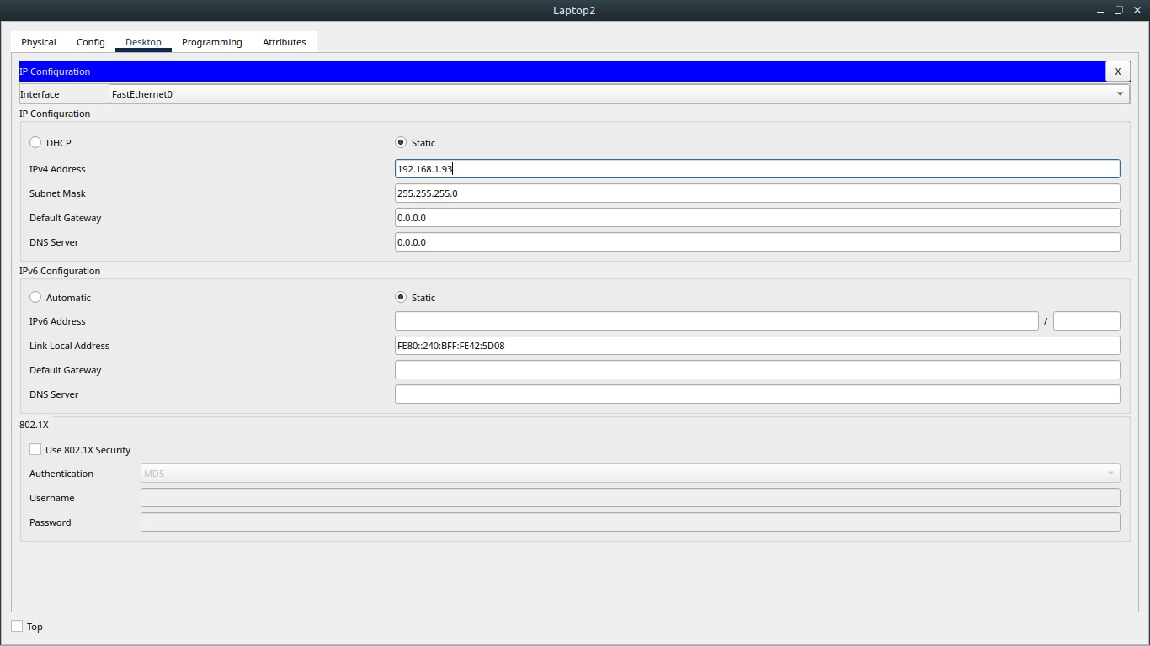

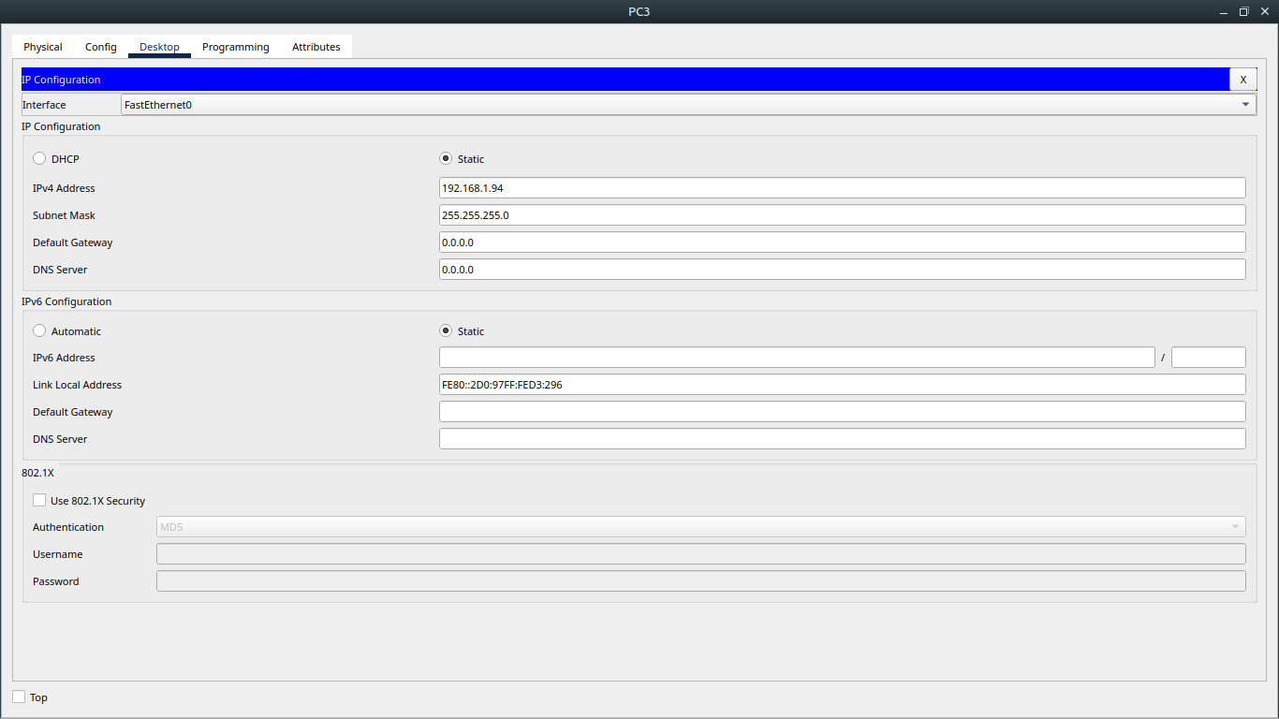

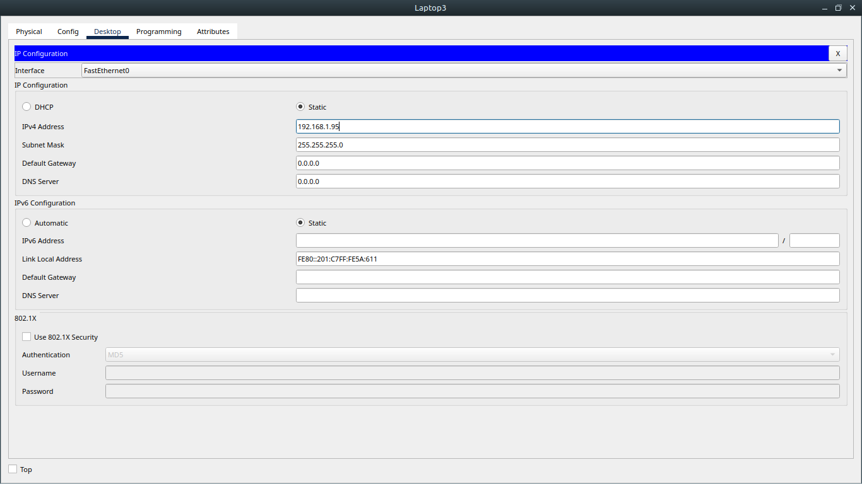

- Here are all the successful connections between End Devices:

